**BIOINFORMATICS ASSIGNMENT 1 (Day 1 - 5)**

**-Pradeep Ram**

***Note: You will be added in a slack community of Bversity for further doubts and communications***

1. Gene Name: TNF

2. Function of the Gene:

* This gene encodes a multifunctional proinflammatory cytokine that belongs to the tumor necrosis factor (TNF) superfamily.
* This cytokine is mainly secreted by macrophages. It can bind to, and thus functions through its receptors TNFRSF1A/TNFR1 and TNFRSF1B/TNFBR.
* This cytokine is involved in the regulation of a wide spectrum of biological processes including cell proliferation, differentiation, apoptosis, lipid metabolism, and coagulation.
* This cytokine has been implicated in a variety of diseases, including autoimmune diseases, insulin resistance, psoriasis, rheumatoid arthritis ankylosing spondylitis, tuberculosis, autosomal dominant polycystic kidney disease, and cancer.
* Mutations in this gene affect susceptibility to cerebral malaria, septic shock, and Alzheimer disease. Knockout studies in mice also suggested the neuroprotective function of this cytokine

3. NCBI accession number: NC_000006.12

4. Forward Primer: ATGTGGCAAGAGATGGGGAA

5. Reverse primer: CTCACACCCCACATCTGTCT

6. Features of primers:

* length- 18 to 28 base pairs
* GC content- 40 to 50%
* Tm of primers- 65˚C to 72˚C

7. Amplicon length and sequence:

* Amplicon/product length- 159
* Sequence-ATGTGGCAAGAGATGGGGAAGAGAGAGAGAGAAAGATGGAGAGACAGGATGTCTGGCACATGGAAGGTGCTCACTAAGTGTGTATGGAGTGAATGAATGAATGAATGAATGAACAAGCAGATATATAAATAAGATATGGAGACAGATGTGGGGTGTGAG

**qPCR Data analysis (DAY 5)**

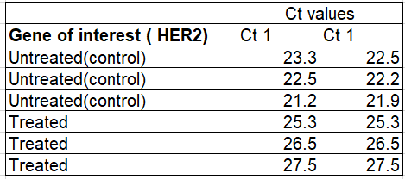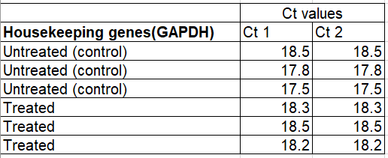

The following data are results of qPCR from cancer cell lines. HER2 stands for human epidermal growth factor. It’s healthy in normal amounts, but too much may be a sign of a certain type of breast cancer. Calculate the 2 Delta Ct values for the following data and plot the values on a graph using Graphpad prism.

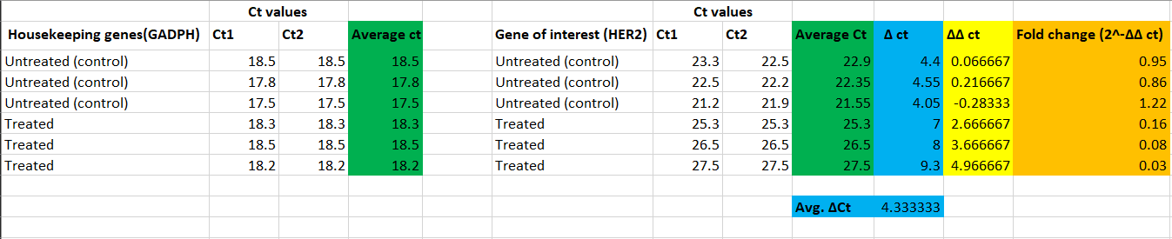**ANSWER=** ΔCt values, ΔΔCt values, Fold change values given in table below: -